Soil Moisture Meter Testing Module

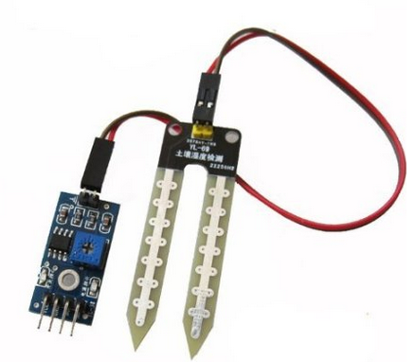
This is a simple water content sensor which can be used to detect soil moisture. It can provide both analog and digital outputs. Analog output can be used to measure the exact moisture content in the soil. While digital output is useful when we want to detect if the soil moisture level crosses a particular level. This level can be easily adjusted using the preset in the panel PCB. This module can be used in Automatic Garden Watering Systems and can be easily interfaced with Arduino Boards, Raspberry Pi, Microcontrollers etc.

Features
- Digital and Analog Outputs
- On-board LM393 comparator
- On-board power indicator LED
- On-board digital switching indicator LED

Specifications
- Operating Voltage : 3.3V ~ 5V
- Sensing Probe Dimensions : 60x30mm
- Panel PCB Dimensions : 30x60mm

Pin Out
PIN | Description
VCC | 5V
GND | Ground
DO | Digital Output Interface
AO | Analog Output Interface
